Name:______________________________Date:_______________

NET Questionnaire
(Please complete both sides)

Primary Complaint:_________________________________________________________________________

How does it affect your life? _________________________________________________________________

________________________________________________________________________________________

Is this the first time you have experienced this problem? Yes No

If no, please describe any treatment you may have previously received for this problem.

_______________________________________________________________________________________________

_______________________________________________________________________________________________

Are you still receiving treatment? Yes No

Are you under a Doctor’s care for any other condition(s)? Yes No

If yes, please describe (include Doctor’s name, condition(s) and type(s) of treatment: __________________

________________________________________________________________________________________________

________________________________________________________________________________________________

________________________________________________________________________________________________

Please list all prescription medications Please list all vitamins & supplements you
you are currently taking: are currently taking:

_________________________________________ ___________________________________________

_________________________________________ ___________________________________________

_________________________________________ ___________________________________________

_________________________________________ ___________________________________________

_________________________________________ ___________________________________________

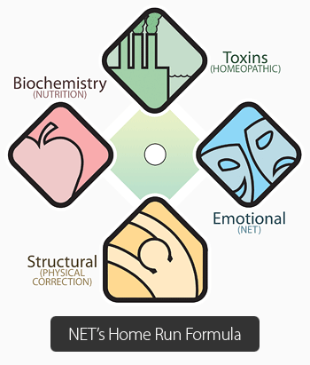
Family Dynamics:
Parents: Living? _____________________________
Deceased? __________________________
Divorced? ___________________________
Remarried? __________________________

Siblings: How many? _________________________
Where are you in the order? ____________
Deceased? __________________________

Rate yourself:
How well do you understand Holistic methods? (please circle one)

0 1 2 3 4 5 6 7 8 9 10
No understanding Understand very well

How open-minded do you feel you are? (please circle one)
0 1 2 3 4 5 6 7 8 9 10
Closed Highly Open-Minded

What type of outcome are you hoping to gain from this treatment?

________________________________________________________________________________________

________________________________________________________________________________________

________________________________________________________________________________________

