Name:______________________________Date:_______________

Lifestyle Questionnaire
(Please complete both sides)

Primary Complaint:_________________________________________________________________________

How long have you had these symptoms? ______________________________________________________

Is this the first time you have experienced this problem? Yes No

If no, please describe any treatment you may have previously received for this problem.

_______________________________________________________________________________________________

_______________________________________________________________________________________________

Are you still receiving treatment? Yes No

Are you under a Doctor’s care for any other condition(s)? Yes No

If yes, please describe (include Doctor’s name, condition(s) and type(s) of treatment: __________________

________________________________________________________________________________________________

________________________________________________________________________________________________

Please list all prescription medications Please list all vitamins & supplements you
you are currently taking: are currently taking:

_________________________________________ ___________________________________________

_________________________________________ ___________________________________________

_________________________________________ ___________________________________________

_________________________________________ ___________________________________________

_________________________________________ ___________________________________________

Have you ever had any serious falls or strains? Yes No (If yes, please explain)

________________________________________________________________________________________________

________________________________________________________________________________________________

Indicate on the figure below where you
are experiencing pain or discomfort:
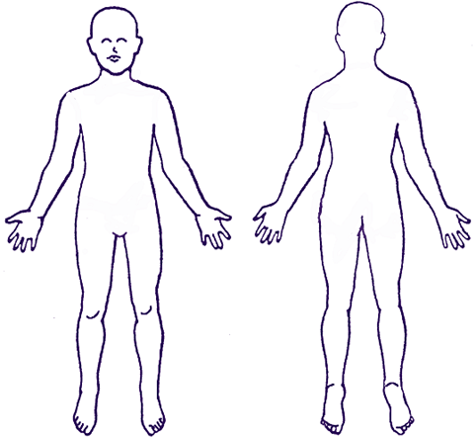
Check all that apply:
Joint Stiffness
Arthritic Tendencies
Extremities cold, clammy
Hands and feet go to sleep easily
Leg nervousness at night
Neck pain or stiffness
Bruise easily
Loss of energy
Susceptible to colds and fevers Depression
Respiratory disorders Headaches
Allergies Blood pressure problem
Difficulty Sleeping Heart Problems
Irritable and restless Indigestion soon after meals
Hungry between meals Constipation
Eat out two or more times a week Stress
Crave Salt Dizziness
Milk products cause distress Diabetes
Eat when nervous Difficulty swallowing

Rank the following from 1 to 4: 1 – none; 2 – light; 3 - moderate; 4 - heavy
_____Alcohol _____Tobacco _____Coffee
_____Drugs _____Exercise _____Soft Drinks

Approximately how many glasses of water do you drink per day? ________(8oz. glasses).

